**ITELL**

**28.02.2025 Conference Opening 1 PM** **MSK Online**

**Session 1. Linguistics and Translation Studies • 1.15 PM** MSK **•** **Online**

Chairs: **Tatyana M. Permyakova, Doctor of Sciences in Language Theory, Professor****;**

**Dmitry S. Tulyakov, PhD in Literature Theory, Associate Professor**

|  |  |  |  |
| --- | --- | --- | --- |
| **№** | **SPEAKER** | **GROUP** | **TOPIC** |
|  | Болтунова Елизавета Алексеевна | Лицей НИУ ВШЭ - Пермь | Comparative Analysis of Professional Translation and AI Translation of Occasional Words in the Fantasy Genre |
|  | Чудинова Олеся Алексеевна | Гимназия №4 имени братьев Каменских, г. Пермь | “Words of the Year” as a Reflection of 2024 |
|  | Белоусенко Ирина Павловна | НИУ ВШЭ, г. Москва | Transliteration in Movie Naming: The Case of the Korean Cinema Industry |
|  | Кравцова Алиса Сергеевна | Астраханский ГМУ Минздрава России, г. Астрахань | Some Features of English Medical Slang |
|  | Морозова Кира Эдуардовна | Московский авиационный институт, г. Москва | Lexical Features of Aviation Terms: Challenges and Solutions in Translation |
|  | Тягней Владислав Владимирович | Ачинский техникум нефти и газа имени Е.А.Демьяненко, г. Ачинск | Blending as a Word Formation Model Aimed to Reflect Social Changes |
|  | Мурашова Валерия Сергеевна | Московский городской педагогический университет,  г. Москва | Grammatical Patterns of American Dialects in Modern Realities: the Comparative Analysis |
|  | Саргсян Мария Аслановна | Южный федеральный университет, г. Ростов-на-Дону | How to Win the Lexis Race: Exploring the Lexical Construction of Kamala Harris’s Image in the 2024 Election |

**Session 2. Management and Career Choice •** **1.15 PM MSK •** **Online**

**Chairs: Ekaterina N. Shestakova, PhD in National History, Associate Professor;**

Tatyana A. Bezrukova, Senior Lecturer

|  |  |  |  |
| --- | --- | --- | --- |
| **№** | **SPEAKER** | **GROUP** | **TOPIC** |
|  | Широков Егор Дмитриевич | Гимназия М.И. Пинаевой,  г. Пермь | The Study Aims to Explore the Influence of AI on Jobs and Professions |
|  | Болотова Диана Олеговна | НИУ ВШЭ - Пермь | Know Your Strengths and Weaknesses and Make the Right Choice: How a Role-Playing Business Game Can Handle Career Choice and Self-Determination of Students and Schoolchildren |
| 1. . | Miss Aunneen Huakhao | Princess Chulabhorn Science High School, Trang | Demand for Different Professions in the Labor Market of Thailand |
| 1. 4 | Догадкина Мария Вячеславовна | Тюменский государственный университет, г. Тюмень | Navigating Dual Identities: Addressing Divergent Online and Offline Personalities in Professional Context |
|  | Федорова Ева Александровна | Гимназия №11  им. С.П. Дягилева, г. Пермь | Modern Trends in Development of Tourism in Russia |
|  | Платонова Александра Денисовна | Гимназия №11  им. С.П. Дягилева, г. Пермь | Mediation in Russia: Beautiful Is Far |
|  | Кожага Яна Орлановна | НИУ ВШЭ - Пермь | The Activities of International Bodies in Ensuring the Protection of National Minority Rights |

Session 3. Social Studies and Psychology• 1.15 PM MSK • Online

**Chairs: Iuliia O. Papushina, PhD in Theory, History and Methods of Sociology, Associate Professor;**

**Natalya Y. Georgieva, PhD in Comparative Linguistics,** Senior Lecturer

|  |  |  |  |
| --- | --- | --- | --- |
| № | SPEAKER | GROUP | TOPIC |
|  | Хахлова Мария Ивановна | Лицей НИУ ВШЭ - Пермь | The Influence of Social Networks on the Lives of Modern Teenagers |
|  | Рыжкова Ирина Алексеевна | НИУ ВШЭ - Пермь | The Impact of Social Media on Youth Behavior in Society |
|  | Канюкова Дарья Сергеевна | Лицей №2, г. Пермь | The Interrelation of Field-Dependence, Field-Independence and Emotional Intelligence |
|  | Хачукаева Влада Александровна | Балтийский федеральный университет им. Иммануила Канта,  г. Калининград | The Problem of Goal Setting in the Modern World |
|  | Борисова Алина Александровна | Лицей НИУ ВШЭ - Пермь | The Relations Between the Hogwarts Houses and Temperamental Properties |
|  | Бурнышева Надежда Алексеевна | Гимназия №11  им. С.П. Дягилева, г. Пермь | Stress Management for Teenagers |
|  | Miss Waratchaya Kwannimit | Princess Chulabhorn Science High School, Trang | Problems of Teenagers in Thailand |
|  | Гагилева Инна Владимировна | Лицей НИУ ВШЭ - Пермь | Romanticization of Psychological Disorders on the Internet and in Modern Society |
|  | Зырянов Артём Николаевич | ПНИПУ, г. Пермь | Cultural Awareness Between Russian and American Students |

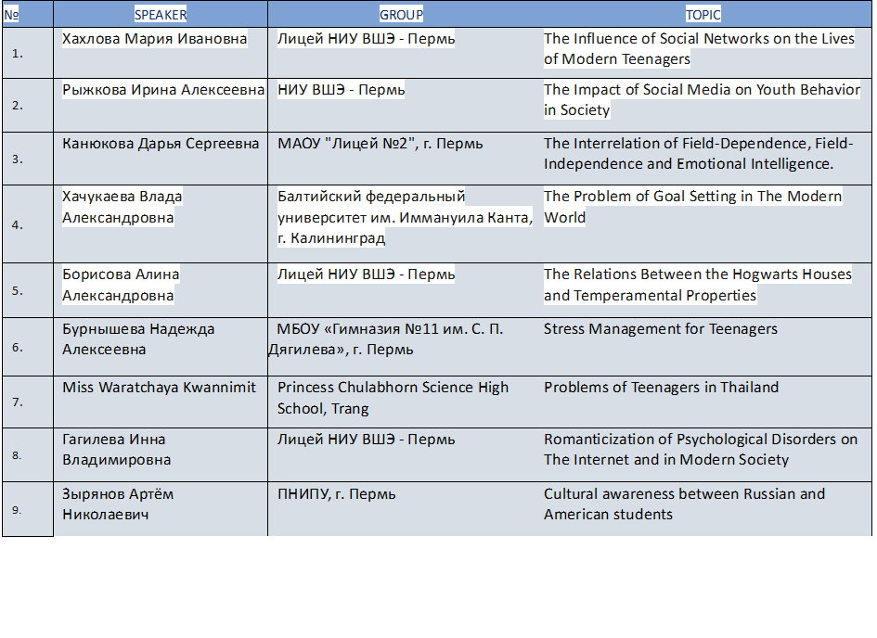**Session 4. Natural Sciences • 1.15 PM MSK •** **Online**

Chairs: **Sofya P. Kulikova, PhD, Associate Professor, Senior Research Fellow;**

**Tatyana I. Utkina, PhD in Language Theory, Associate Professor**

|  |  |  |  |
| --- | --- | --- | --- |
| **№** | **SPEAKER** | **GROUP** | **TOPIC** |
| 1. | Федоскова Мария Дмитриевна | Гимназия №17,  г. Петрозаводск | Aluminum Mass Concentration Determination by Photometric Method and Comparative Analysis of Its Content in Natural and Purified Drinking Water |
| 2. | Кауфман Таисия Львовна | Гимназия №17,  г. Петрозаводск | Water Hardness Determination Using the Complexometric Method and Study of Hardness Removal Methods |
| 3. | Хлобыстова Алиса Сергеевна | УрФУ им. первого президента России  Б.Н. Ельцина,  г. Екатеринбург | Determination of Acidity and Calcium Ion Content in Fermented Dairy Products |
| 4. | Косов Арсений Андреевич | ПГМУ им. ак. Е.А. Вагнера,  г. Пермь | The Role of Pharmacogenomics in the Health Preservation of the Family and Educational Organizations |
| 5. | Бабинович Анастасия Евгеньевна | Национальный исследовательский Томский государственный университет, г. Томск | Peculiarities of Numerical Calculation of Light Scattering on Ice Crystals |

**Session 5. Education and IT • 1.15 PM MSK • Online**

**Chairs:** Ekaterina A. Balezina, PhD in Social Science, Research Fellow;

Natalya E. Ryapina, Senior Lecturer

|  |  |  |  |
| --- | --- | --- | --- |
| № | SPEAKER | GROUP | TOPIC |
|  | Житенева Марина Константиновна | Московский финансовый колледж федерального государственного образовательного бюджетного учреждения высшего образования "Финансовый университет при Правительстве Российской Федерации",  г. Москва | On Factors Shaping Teenagers' Reading Trends in the Digital Age |
|  | Огородова Юлия Игоревна | ПНИПУ, г. Пермь | Digital Communications of Online Schools: the Role of Feedback |
|  | Шабатина Александра Сергеевна | Гимназия №11  им. С.П. Дягилева, г. Пермь | Artificial Intelligence and Its Impact on Teenagers Studies |
|  | Такпешев Николай Николаевич | Ачинский техникум нефти и газа им. Е.А.Демьяненко,  г. Ачинск | Chatbots as a Tool for Organizing Students' Independent Work on Developing Foreign Language Skills |
|  | Иванова Анастасия Владимировна | Псковский государственный университет, г. Псков | Didactic Potential of ChatGPT in Teaching Vocabulary in Secondary School |
|  | Данилов Александр Игоревич | Северный (Арктический) федеральный университет  им. М.В. Ломоносова,  г. Архангельск | Developing Sociocultural Competence in English Lessons for Seventh Graders Through the Use of Linguistic and Cultural Media Texts About Great Britain |
|  | Гордеева Дарья Антоновна | Гимназия №11  им. С. П. Дягилева, г. Пермь | Learning Foreign Languages in Modern Realities |

**Session 6. Advertising and Marketing • 1.15 PM MSK •** Online

Chairs: Aleksandra I. Sazhina, PhD in Economics, Associate Professor;

Olga L. Antineskul, PhD in Language Theory, Associate Professor

|  |  |  |  |
| --- | --- | --- | --- |
| № | SPEAKER | GROUP | TOPIC |
|  | Стерлядева Екатерина Владимировна | ПНИПУ, г. Пермь | The Effectiveness of Promoting Fashion-Brands in the Regional Market (Using the Example of "Starikova") |
|  | Плешкова Татьяна Вадимовна | ПНИПУ, г. Пермь | The Role of Semantic and Stylistic Elements of Video Advertising in Constructing the Image of an Organization (on the Example of Russian Banks) |
|  | Дидык Анжелика Сергеевна | ПНИПУ, г. Пермь | Perception of an Advertising Text by Diverse Target Audiences |
|  | Кобелев Михаил Олегович | Лицей НИУ ВШЭ - Пермь | The Impact of AI-Generated Music on Video-Advertising |
|  | Душейко Мария Антоновна | НИУ ВШЭ - Пермь | How the Quantity of Product Offered Affects Its Appeal |
|  | Сметанова Олеся Игоревна | ПНИПУ, г. Пермь | Content Analysis of Confectionery Social Networks |
|  | Бисярина Настасья Евгеньевна | ПНИПУ, г. Пермь | The Perception of High-Tech Brands in the Medtech Industry |